NAME: MALOTH ADITYA
ROLL NO.: 120CS0124

Q.1 Read the instructions and run the simple client server program givenin help document (TCP_Socket1.doc).

Client Code:
/*TCP_Client*/
#include <sys/types.h>
#include <sys/socket.h>
#include <netinet/in.h>
#include <arpa/inet.h>
#include <stdio.h>
#include <unistd.h>
#include <stdlib.h>
int main()
{
int sid;
char c;
struct sockaddr_in server_address;
int server_addlen;

server_address.sin_family=AF_INET;

server_address.sin_addr.s_addr=inet_addr("127.0.0.1");

server_address.sin_port=5080;

server_addlen=sizeof(server_address);

sid=socket(AF_INET,SOCK_STREAM,0);

connect(sid,(struct sockaddr *)&server_address,server_addlen);

write(sid,"A",1);
read(sid,&c,1);

printf("Char from server is %c\n",c);
close(sid);
return(0);
}

Server Code:
/*TCP_Server*/
#include <sys/types.h>
#include <sys/socket.h>
#include <netinet/in.h>
#include <arpa/inet.h>
#include <stdio.h>
#include <unistd.h>
#include <stdlib.h>
int main()
{
int serid,sessid;
char c;
struct sockaddr_in server_address,client_address;

unsigned int server_addlen,client_addlen;

server_address.sin_family=AF_INET;
server_address.sin_addr.s_addr=inet_addr("127.0.0.1");
server_address.sin_port=5080;

server_addlen=sizeof(server_address);
client_addlen=sizeof(client_addlen);

serid=socket(AF_INET,SOCK_STREAM,0);

bind(serid,(struct sockaddr*)&server_address,server_addlen);

listen(serid,10);

while(1)
{
printf("Server is ready to accept ......\n");
sessid=accept(serid,(struct sockaddr *)&client_address,&client_addlen);
read(sessid,&c,1);
write(sessid,&c,1);
close(sessid);
}
return(0);
}

Output:
Client Output:
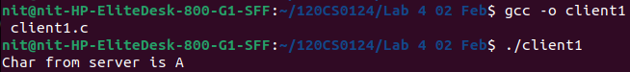
Server Output:
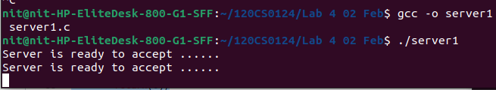

Q.2 Execute a client/server program for adding a two integer numbers requested by the client and evaluated at server and get back result at the client. You will be appreciated if you use command line arguments. (You can input ip address of the machine at the time of execution)(Hint: Use TCP_Socket2.doc file)

Client Code:
/*TCP_Client*/
#include <stdio.h>
#include <string.h>
#include <sys/socket.h>
#include <arpa/inet.h>

int main(int argc, char *argv[]) {
int client_socket;
struct sockaddr_in server;
int num1, num2, result;

client_socket = socket(AF_INET, SOCK_STREAM, 0);
if (client_socket == -1) {
printf("Could not create socket");
return 1;
}

server.sin_addr.s_addr = inet_addr("127.0.0.1");
server.sin_family = AF_INET;
server.sin_port = htons(5000);

if (connect(client_socket, (struct sockaddr *)&server, sizeof(server)) < 0) {
printf("Connect failed");
return 1;
}

printf("Enter first number: ");
scanf("%d", &num1);
printf("Enter second number: ");
scanf("%d", &num2);

num1 = htonl(num1);
num2 = htonl(num2);
send(client_socket, &num1, sizeof(num1), 0);
send(client_socket, &num2, sizeof(num2), 0);
recv(client_socket, &result, sizeof(result), 0);
// result = ntohl(result);

printf("Result: %d\n", result);

close(client_socket);

return 0;
}

Server Code:
/*TCP_Server*/
#include <stdio.h>
#include <string.h>
#include <sys/socket.h>
#include <arpa/inet.h>

int add_numbers(int num1, int num2) {
return num1 + num2;
}

int main(int argc, char *argv[]) {
int server_socket, client_socket;
struct sockaddr_in server, client;
int c;
int num1, num2, result;

server_socket = socket(AF_INET, SOCK_STREAM, 0);
if (server_socket == -1) {
printf("Could not create socket");
return 1;
}

server.sin_family = AF_INET;
server.sin_addr.s_addr = INADDR_ANY;
server.sin_port = htons(5000);

if (bind(server_socket, (struct sockaddr *)&server, sizeof(server)) < 0) {
printf("Bind failed");
return 1;
}

listen(server_socket, 3);

printf("Waiting for incoming connections...\n");
c = sizeof(struct sockaddr_in);

while ((client_socket = accept(server_socket, (struct sockaddr *)&client, (socklen_t*)&c))) {
printf("Connection accepted from %s:%d\n", inet_ntoa(client.sin_addr), ntohs(client.sin_port));
recv(client_socket, &num1, sizeof(num1), 0);
recv(client_socket, &num2, sizeof(num2), 0);
result = add_numbers(ntohl(num1), ntohl(num2));
send(client_socket, &result, sizeof(result), 0);
close(client_socket);
printf("Connection closed\n");
}

if (client_socket < 0) {
printf("Accept failed");
return 1;
}

return 0;
}

Output:
Client Output:
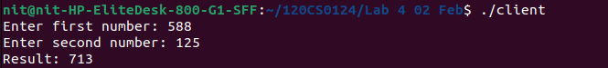
Server Output:
